First create s3 bucket with all default settings

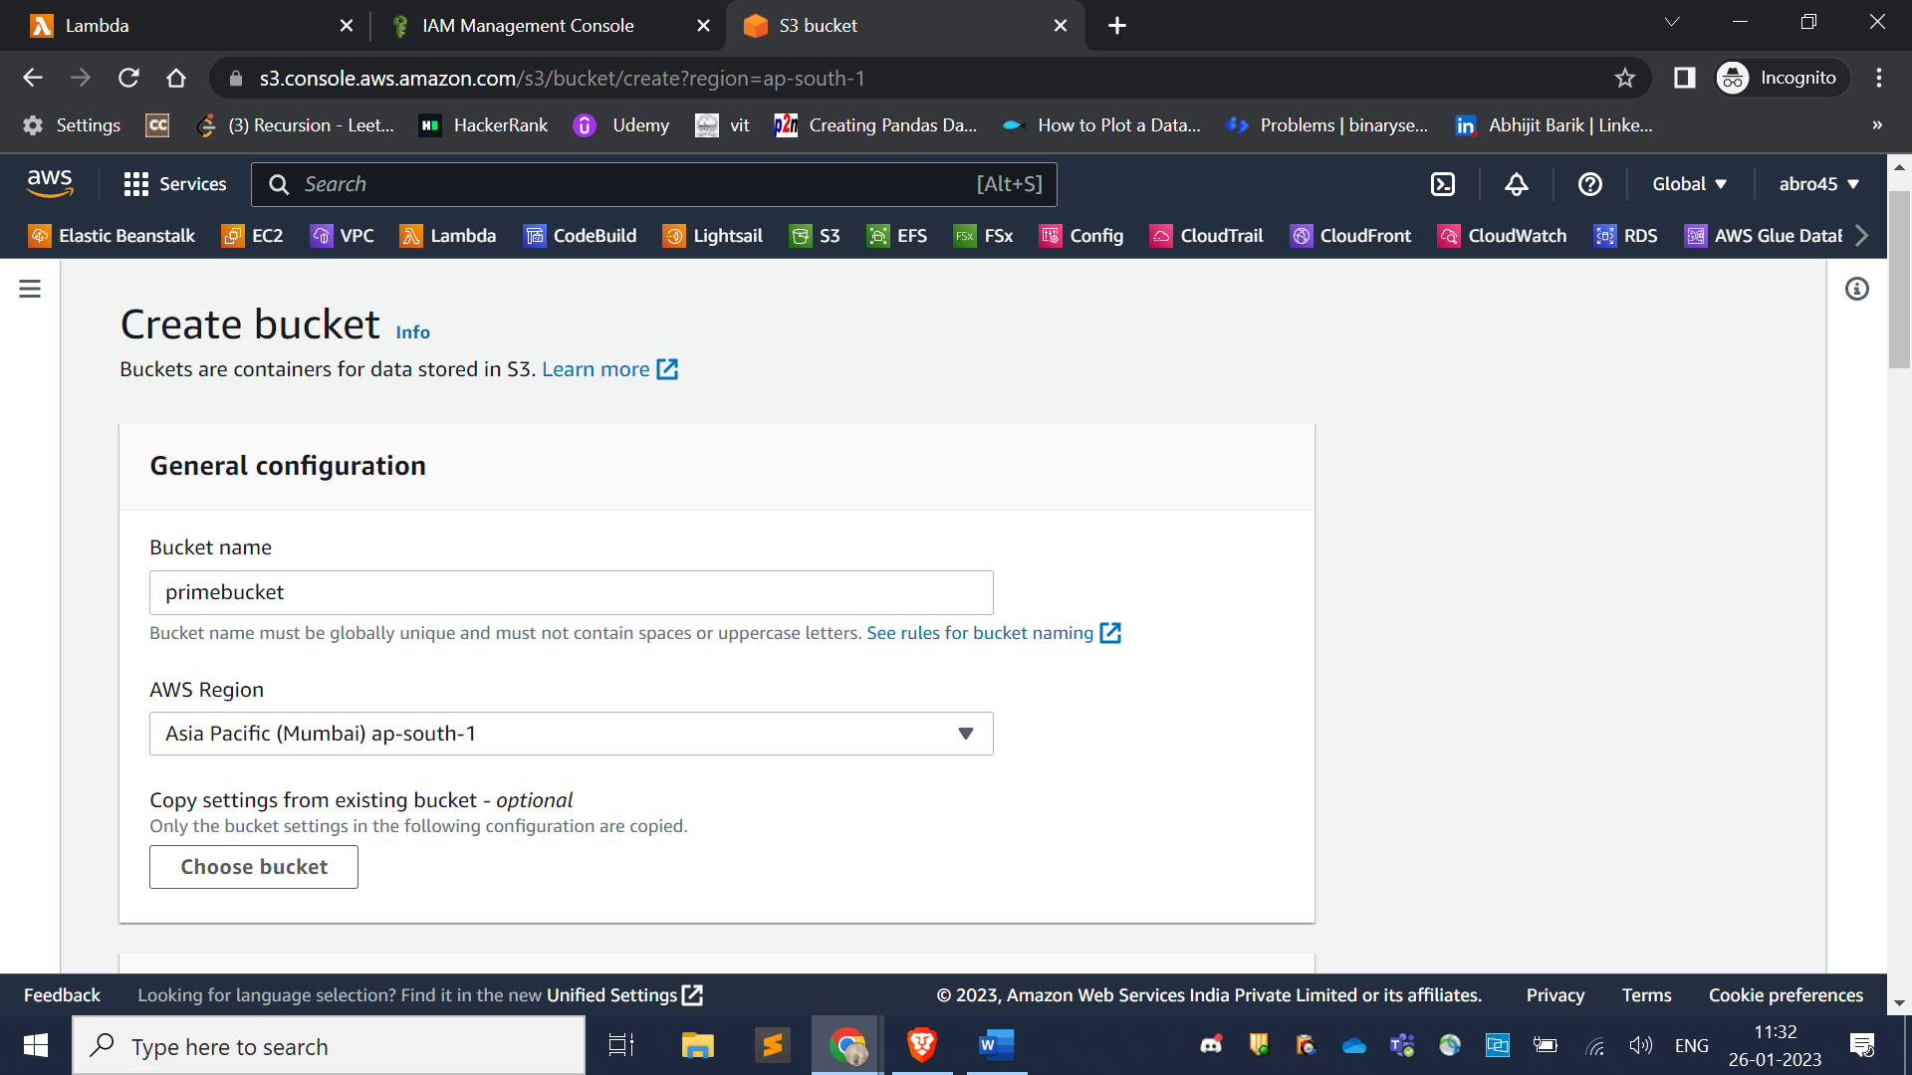

Then upload data into you into newly created bucket

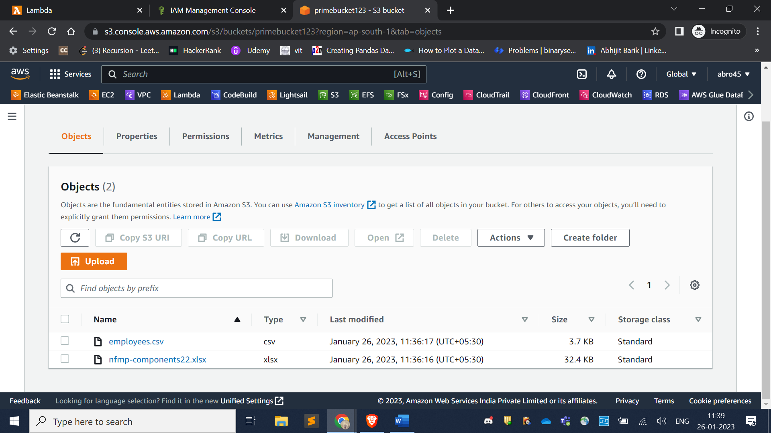

Then create IAM role

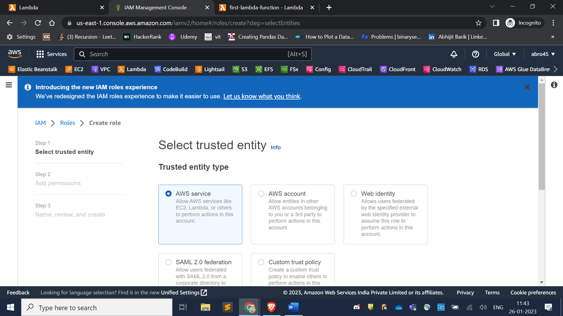

Use case type must be lambda as we are working on lambada

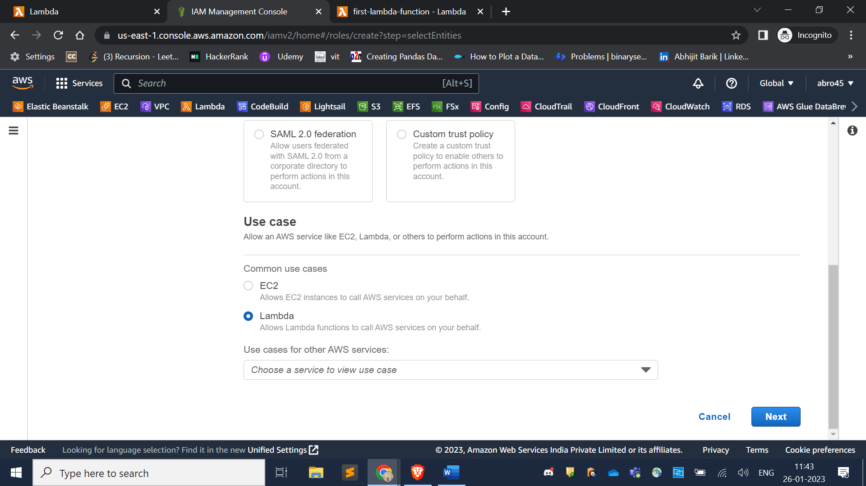

Then Select AWSLambdaBasicExecution policy

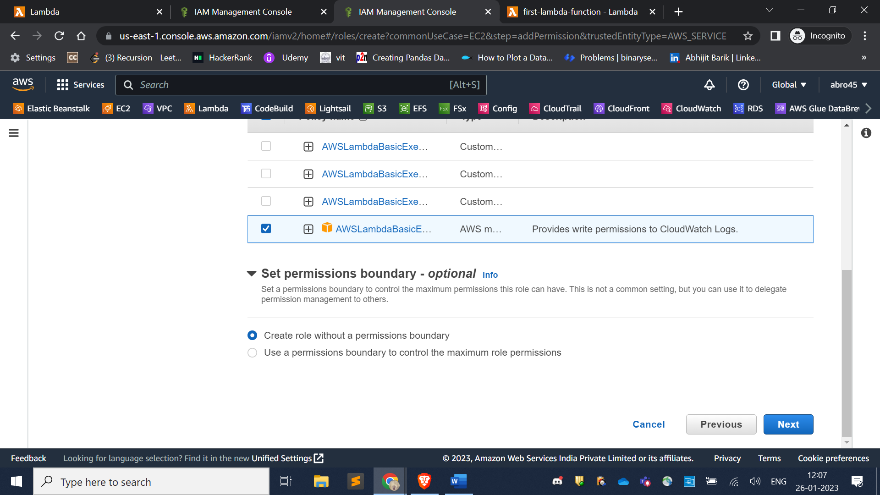

Then give assign a role name like s3bucketrole

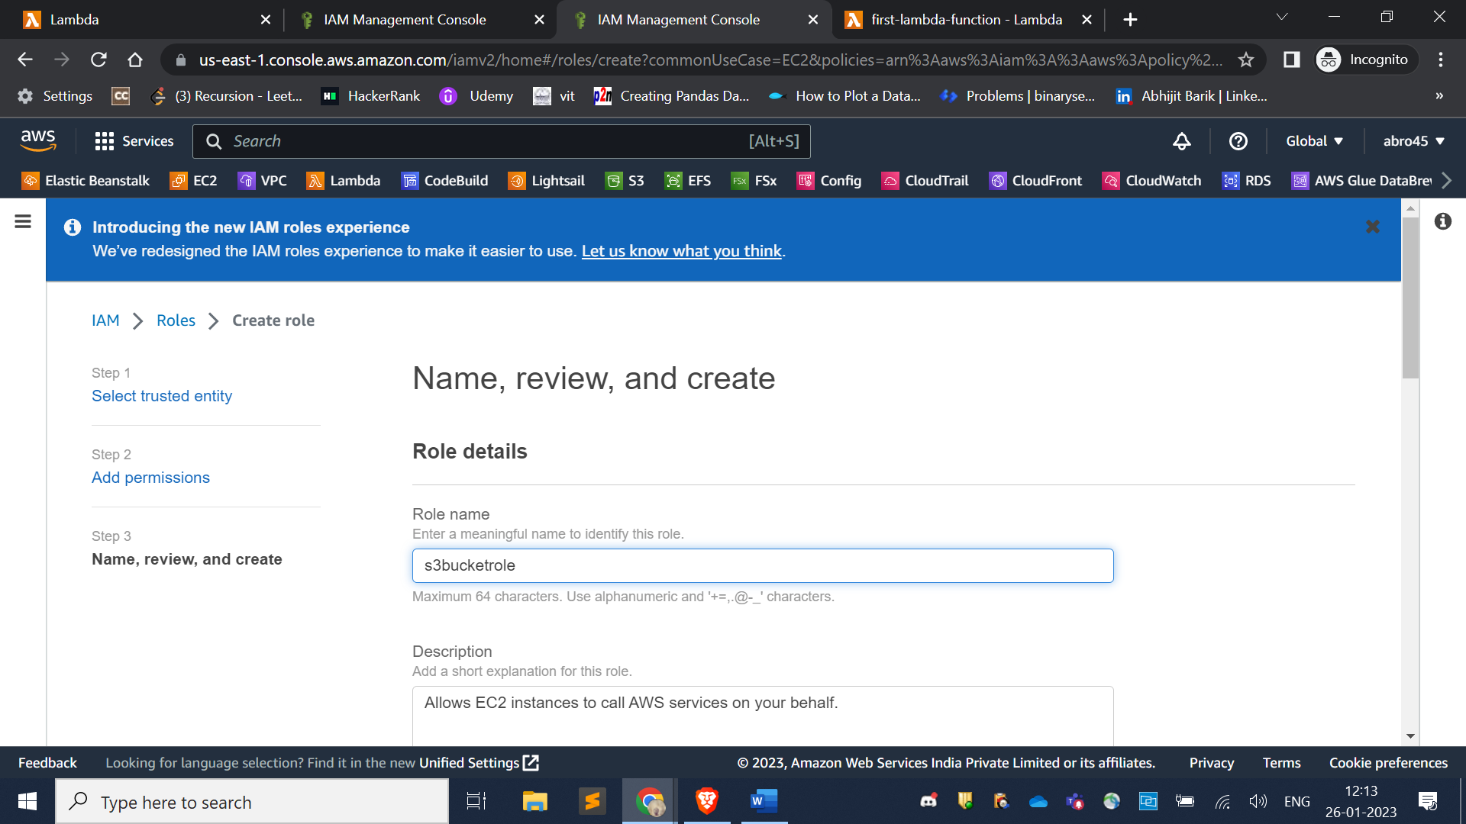

Then click on to your newly created bucket role and create a inline policy

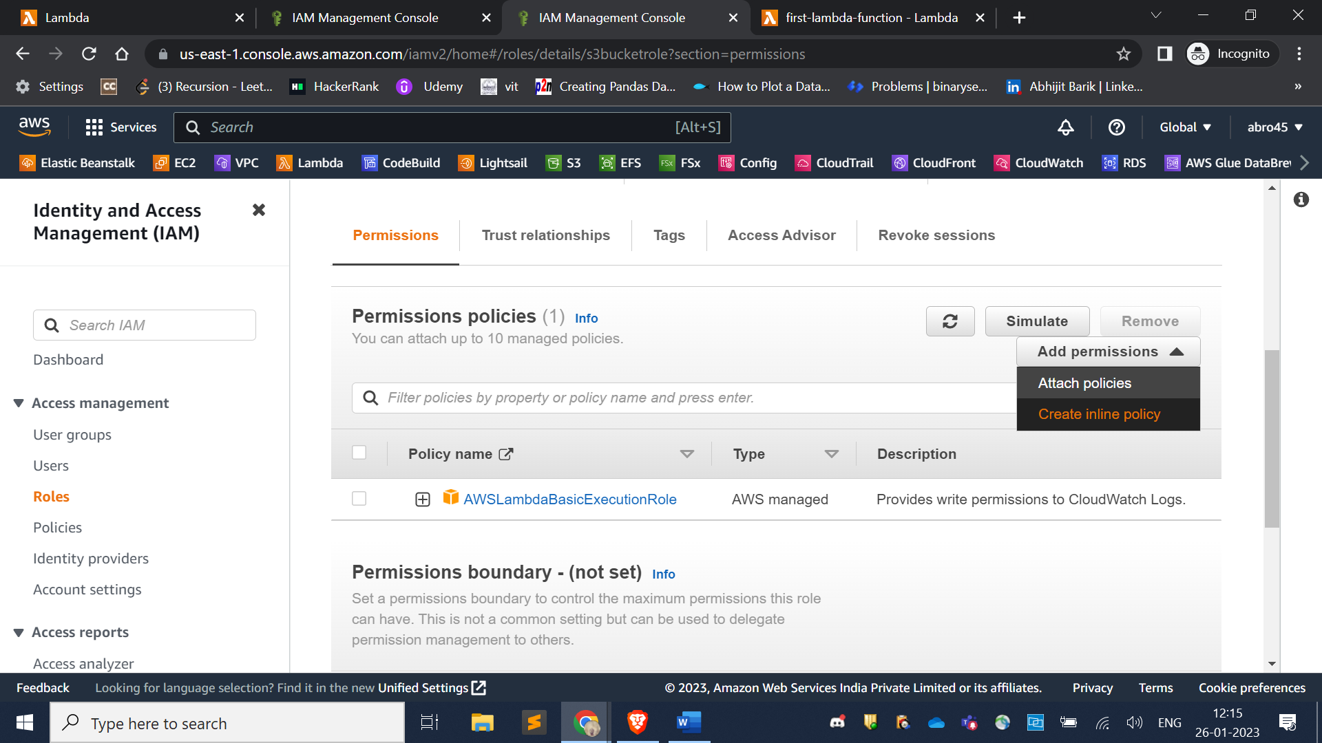

Then chose s3 in service section

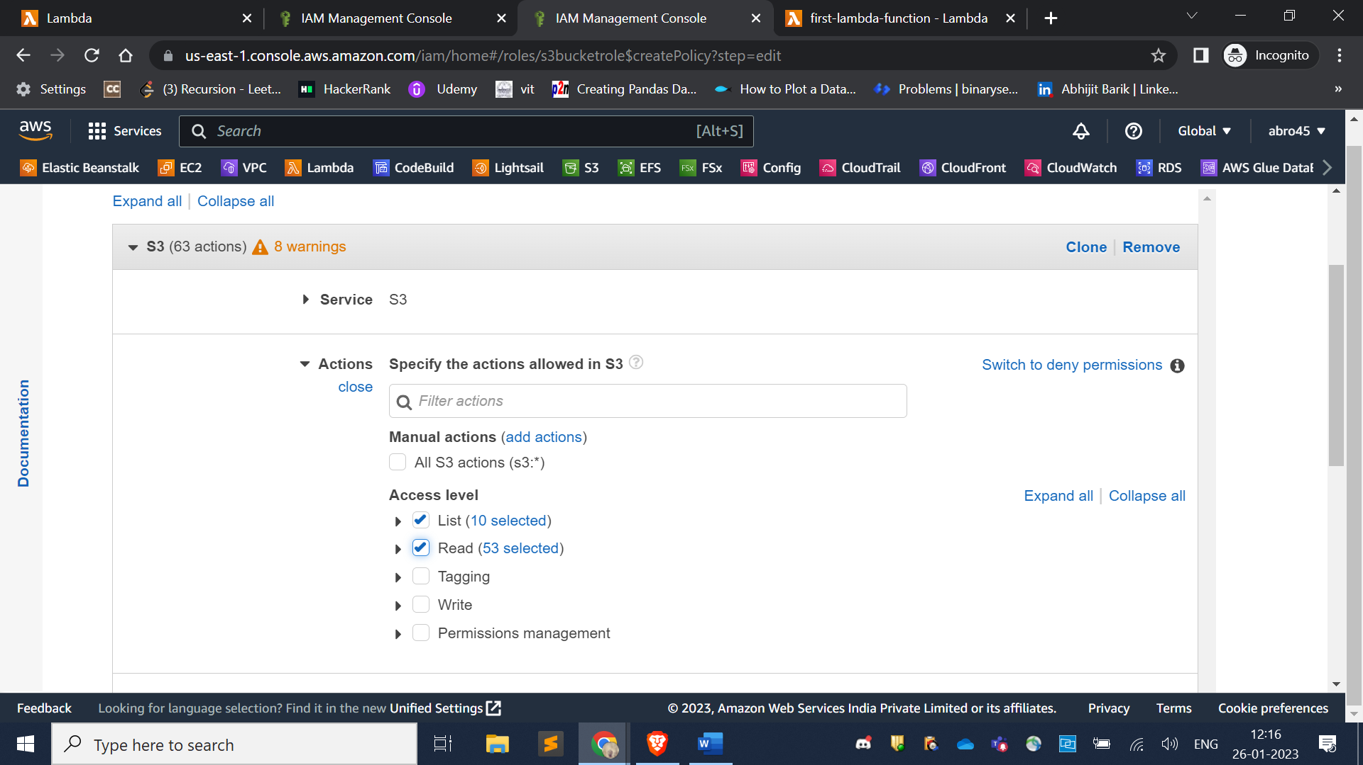

Then chose specific in resource section

Then click add ARN in bucket section

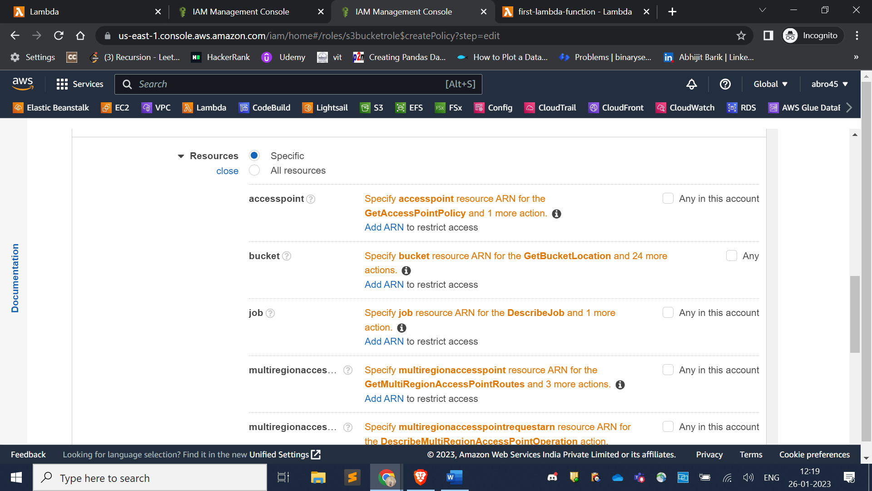

Put your bucket name add ARN option to get access of your bucket

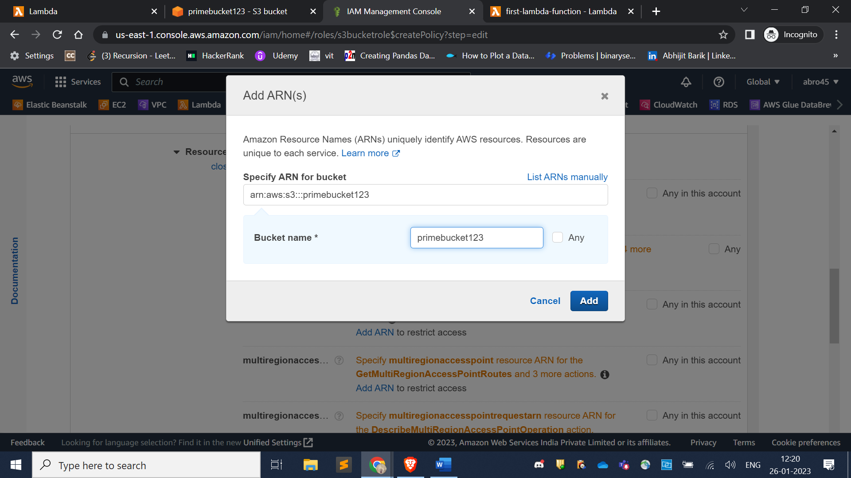

Then create a lambda function from scratch using python runtime

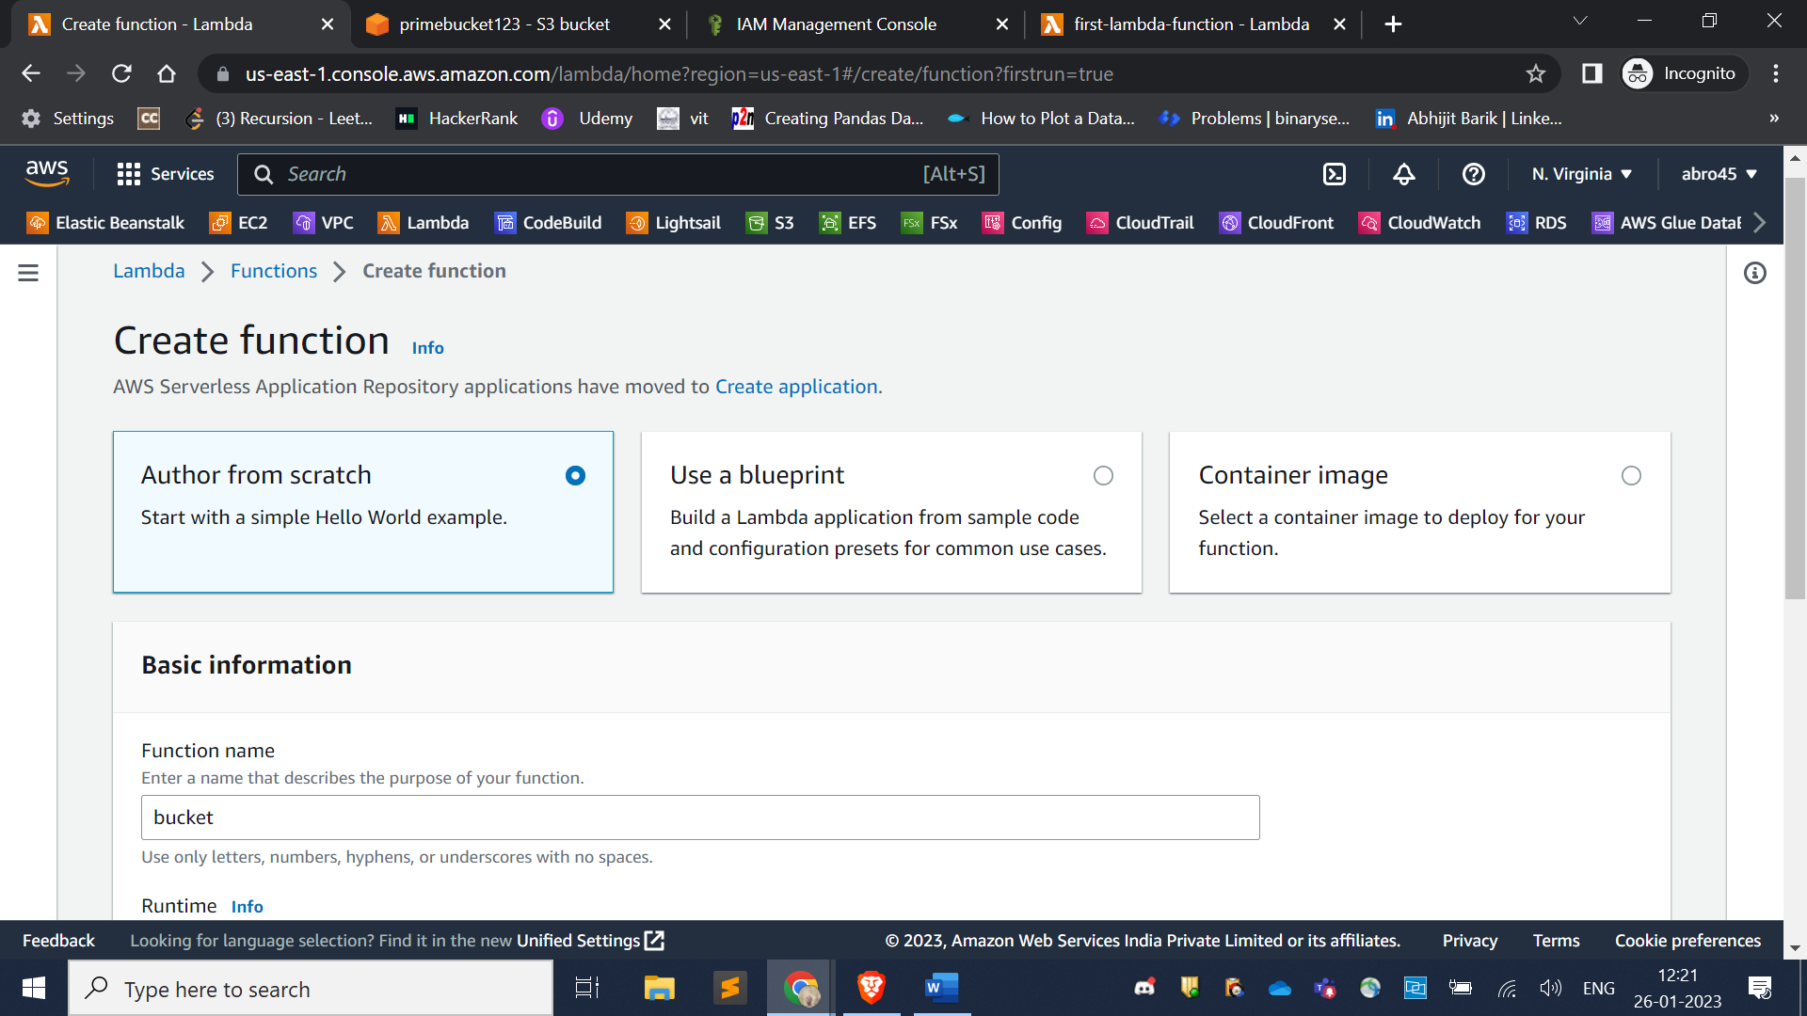

write this code snippet to get file name from s3 bucket

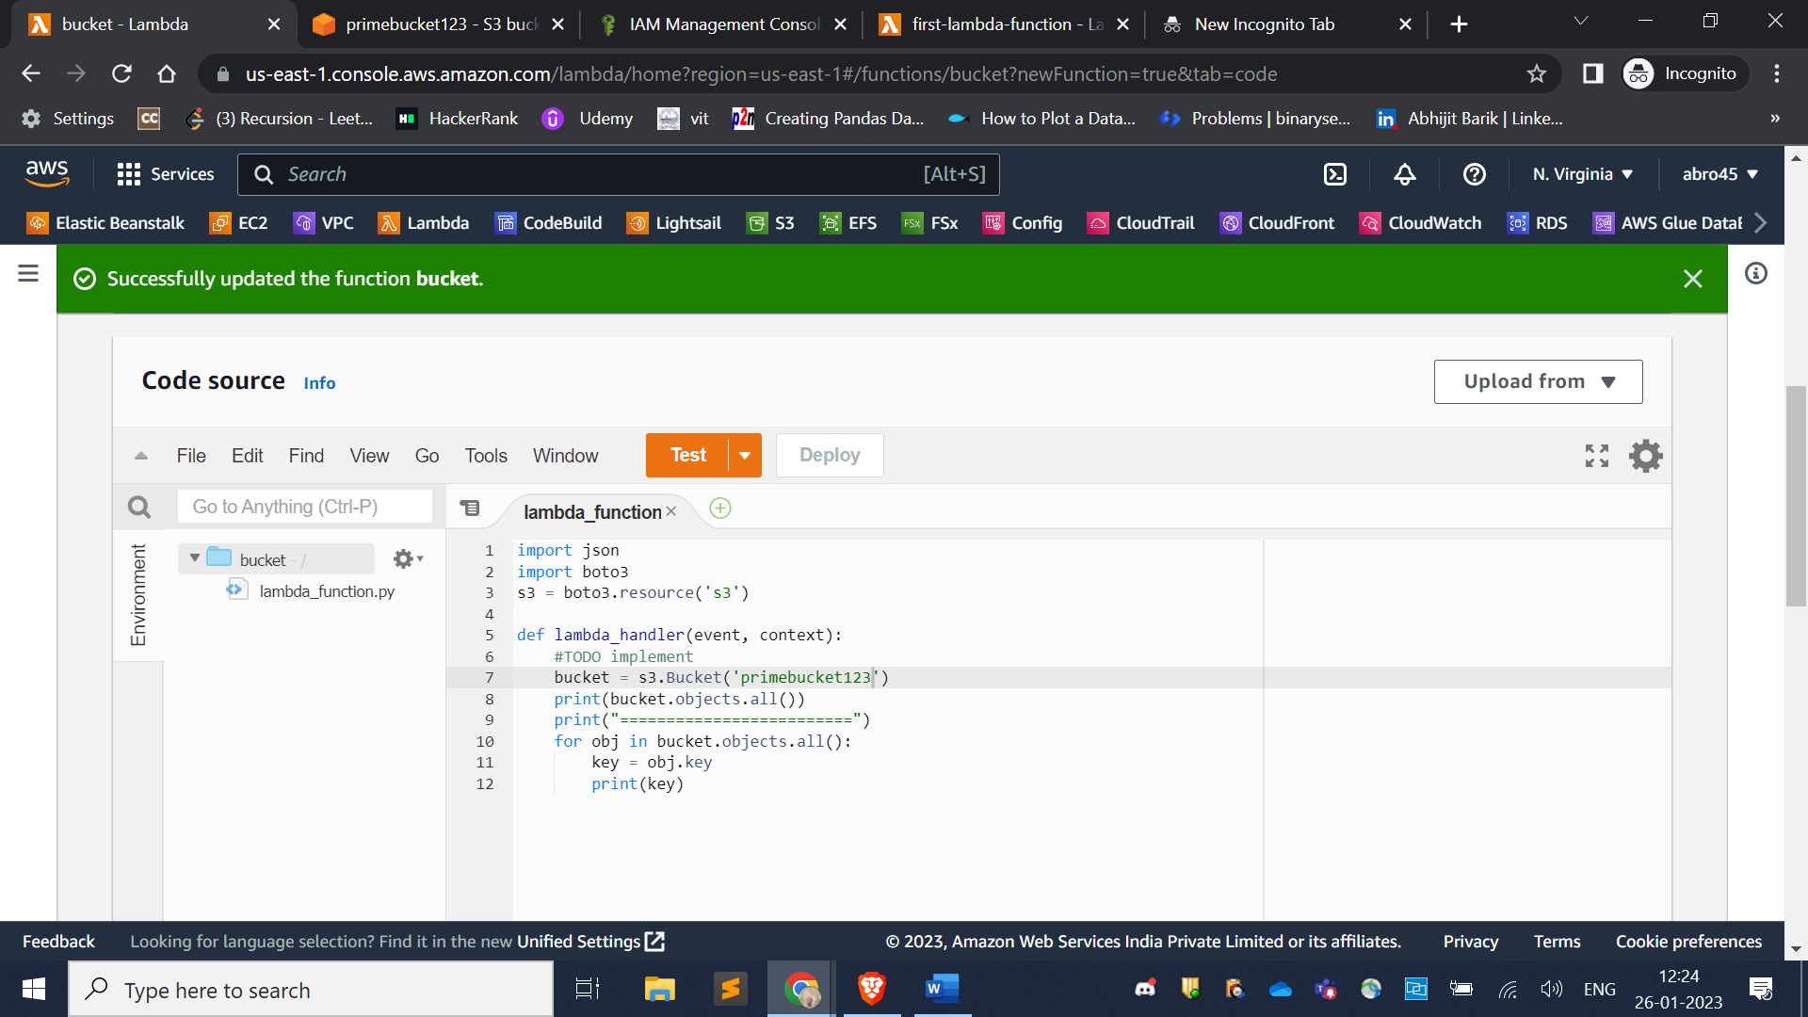

After writing code just deploy it.

Then go to configure tab and edit execution role

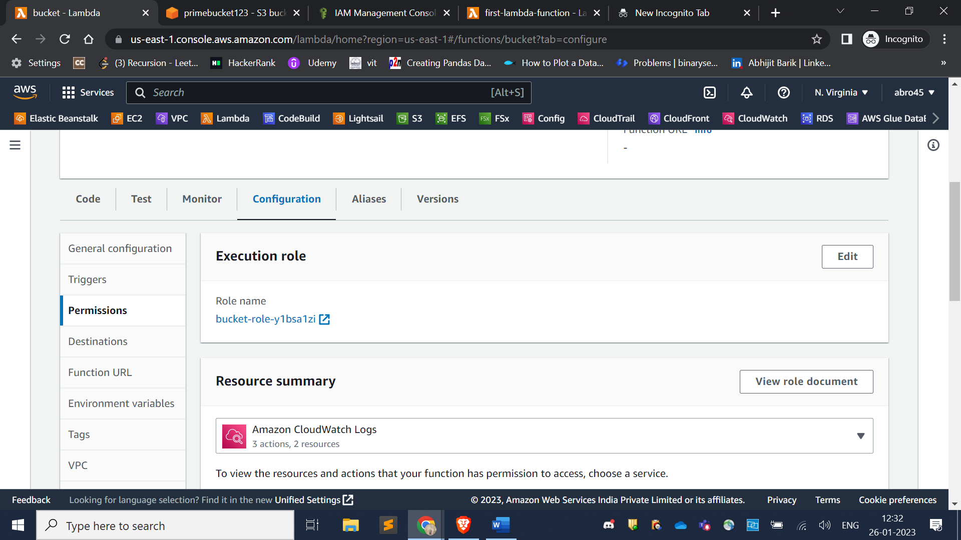

Chose what role you created in IAM section and save it

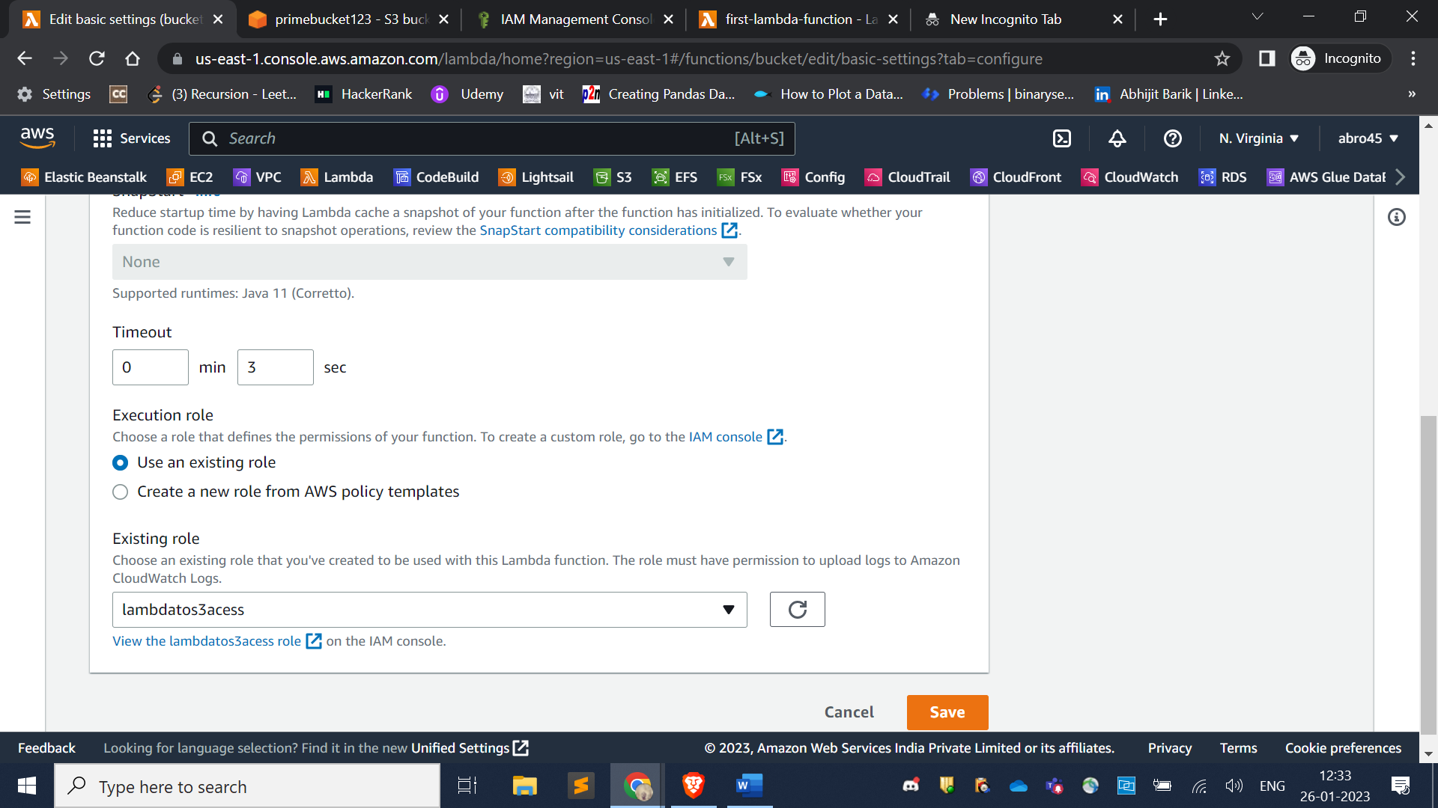

Now you can test your lambda function

